I CLICK TO SUB MENU BUT IT SHOWS A PRODUCT INSTEAD

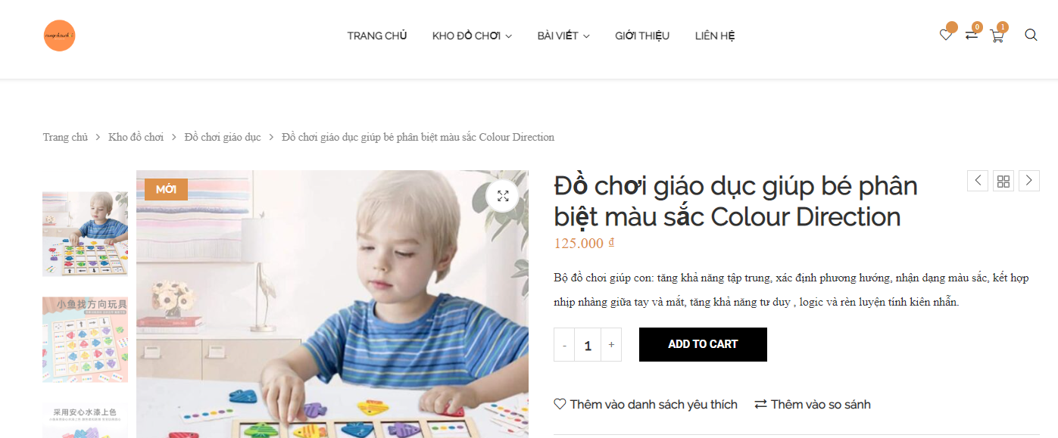

AND THIS IS THE SECOND SUB MENU

